Weekly Newsletter
Dear Parents and Carers,
There has been a real buzz around the school this week as pupils interacted and learned lots of new things, giving such a positive vibe to everyone.
Out SidYouth partners have increased their support for EducateU by offering even more pupils the chance to develop their social and emotional skills in a variety of on and off-site activities. We understood some of the apprehensions some of our pupils had when introduced to this programme, but these were soon quashed as they participated in their first liaisons with staff. We look forward to sharing more exciting news about SidYouth in the future.
The preparations for our Culture Week have begun: this term we are focusing on the Royal Jubilee. We appreciate the Queen may be a bit busy to pay us a visit in person but that will not stop us creating a learning wall which will include information gathered across secondary to commemorate the event which I am sure Her Majesty will be proud of.
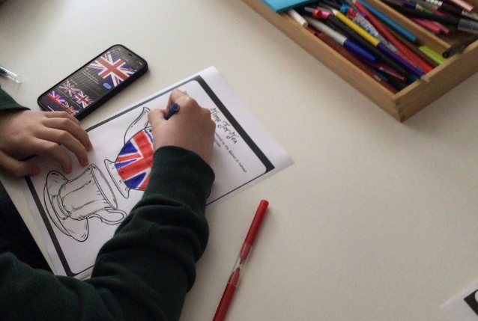
ASDAN has been high on the agenda too. This scheme of work fits perfectly into the learning preferences for our pupils, given the flexibility of topics and differentiation. As always, we expect the very best in terms of efforts and focus, our pupils have risen to the challenge of writing reviews of venues they have visited, involved themselves with art projects, including researching Five Nights at Freddy, recreating his costume (more pictures to follow!), creative artwork in a ‘tattoo’ format using I.T research, and making cheesecake!
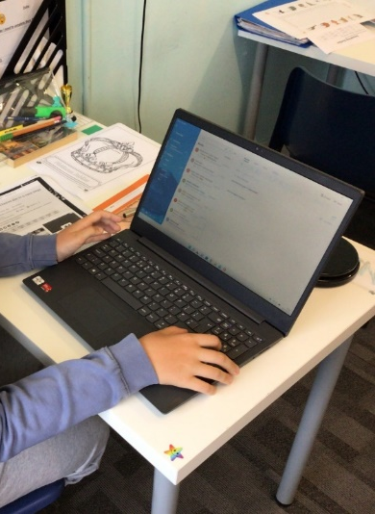
Maths has seen pupils overcome their fear of angles; apparently, they are now not so scary and our Communication work is progressing well, with pupils using their five senses, sight, sound, taste, touch, and smell to support their descriptive writing focus.
Our Competency topic, Friendship, has linked up with our work to support ‘Mindfulness Week’, where pupils have really thought hard about what makes a good friend, then reflect on their own strengths and area for development.
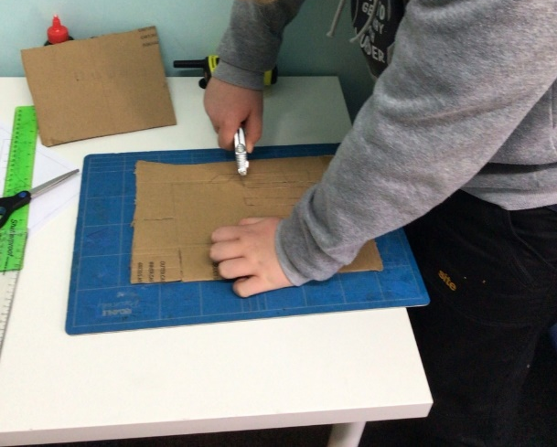
STEM lessons have teamed up with our Passport challenge by learning how to create flick books and then create one.

Our new venue to host Outdoor Education has proved very popular all-round. We accept many of our pupils are reluctant to change but when they visited the site, met the owner, and explored the area it was a thumbs up all round. One person was very excited about the vintage tractor used at the site. I’m sure he will be back every week and may even get to have a drive!
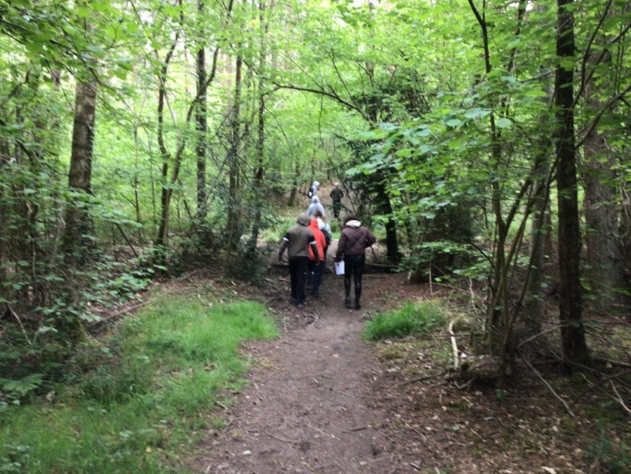
Two of our key stage four pupils have excelled themselves this week by supporting staff and pupils in primary to organise a trip to Paulton’s Park. They were given the task to help book tickets, arrange minibuses, organise timetables, and most importantly on the day manage pupils to ensure they had a safe and enjoyable time. Please believe us when we say organising a trip is not a five-minute job and we are so proud of these two pupils who were so proactive, thoughtful, and organised from the outset. As we explained to them, the skills they demonstrated with such confidence are so sought after by interviewers whether it be further education provision or future employers, so again huge congratulations to them.
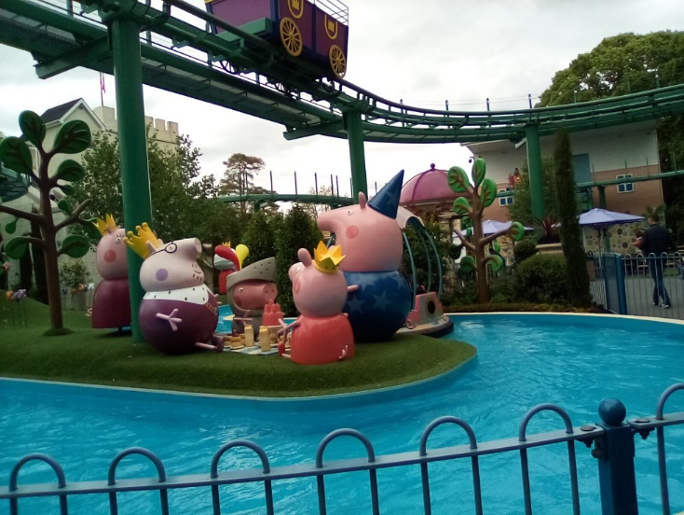
We couldn’t forget to mention that one of our amazing Learning Support Assistants has celebrated a very significant birthday this week. Pupils and staff have all celebrated with her, not only for the special day but the support and love she shares with staff and pupils on daily basis which we are so grateful for.
Best wishes,
The secondary team

