Weekly Newsletter
Dear Parents and Carers.
Wow what a fabulous week we have had!
Our competency topic ‘Gothic England’, is really taking off, with some looking at the Great Plague, its origins and effects including the impact it had on society and future generations. Others have been looking at gothic symbolism and how it was incorporated into both architecture and literature. This has been reflected in some art lessons with students designing and making stained- glass windows and sketching and then modelling some clay gargoyle sculptures!
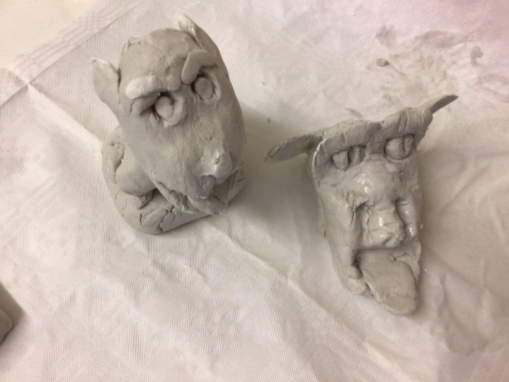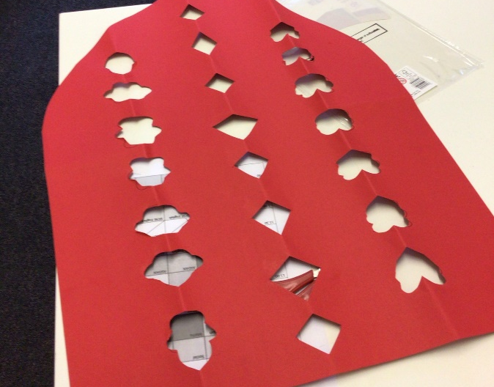
Some students have been very focussed on their Key Steps project. One of the projects is the Fortnam and Mason's Queen's platinum jubilee pudding competition, where shortlisted designs are judged by an array of top pudding chefs and include Mary Berry!
GCSE students are continuing to engage with Lord of the Flies, discussing leadership qualities and imagining real-life scenarios of how they could put these skills to the test. They also debated what the ‘beast’ was and why with human nature we create and use fear to keep us safe! GCSE Math students have been learning not only multiplying with decimals but understanding the importance of showing clear, working methods. This is crucial to gaining extra exam marks when they sit the real thing, allowing each student to demonstrate and fulfil their true potential.

The highlight of this week has to be one of our ASDAN students feeding the whole school! He planned, provided and cooked not one menu but two, as he offered a traditional chili con carne but also made a bespoke vegan option too. This was not enough for him so he ensured that he also prepared a fresh garnish, accompanying warm, bread rolls, and a cream dip to really add the luxurious and gourmet factor! The rice was also cooked to perfection and using a volunteering peer, it was dished up without fuss so that everyone, and that means over 40 portions were served up quickly and professionally so that the experience could really be compared to the style and standard of a Michelin Star restaurant!
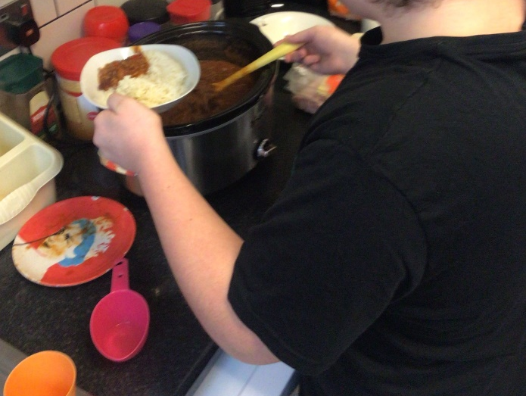
Another amazing highlight was the High Sheriff of Sussex had heard about our great school and all the innovative things we have been achieving and invited himself to visit. He was dressed for the occasion in fill regalia including his shiny ceremonial sword! One of our students acted as his tour guide, and he saw our school in full flow with its vibrancy and enthusiastic children who certainly asked him a question or two!
Best wishes
The Secondary Team

